**CLIENT CODE**

**Client – 1**

**CODE:**

import socket

s1=socket.socket(socket.AF_INET,socket.SOCK_STREAM)

s1.connect((socket.gethostname(),2000))

print("*****************TRUCK 1 ACTIVE***************")

while True:

k=s1.recv(1024).decode('ascii')

if(len(k)>0):

print(k)

else:

break

z='('+k+')'+' Order Completed'

s1.sendall(z.encode())

s1.close()

**CODE IMAGE:**

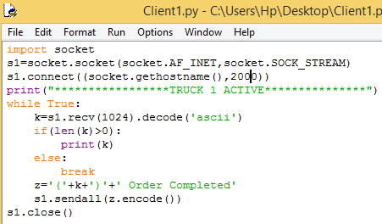

**Client-2**

**CODE:**

import socket

s2=socket.socket(socket.AF_INET,socket.SOCK_STREAM)

s2.connect((socket.gethostname(),2001))

print("*****************TRUCK 2 ACTIVE*************")

while True:

k=s2.recv(1024).decode('ascii')

if(len(k)>0):

print(k)

else:

break

z='('+k+')'+' Order Completed'

s2.sendall(z.encode())

s2.close()

**CODE IMAGE:**

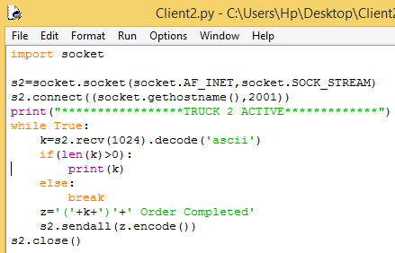

**Client-3**

**CODE:**

import socket

s3=socket.socket(socket.AF_INET,socket.SOCK_STREAM)

s3.connect((socket.gethostname(),2002))

print("*****************TRUCK 3 ACTIVE*************")

while True:

k=s3.recv(1024).decode('ascii')

if(len(k)>0):

print(k)

else:

break

z='('+k+')'+' Order Completed'

s3.sendall(z.encode())

s3.close()

**CODE IMAGE:**

